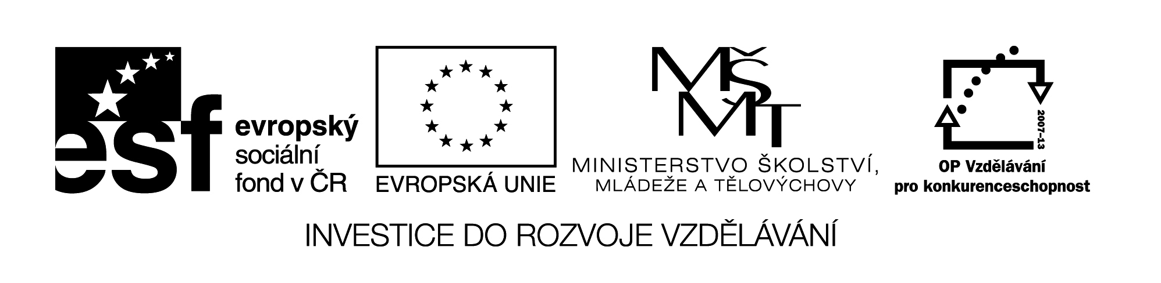
Název školy: Střední průmyslová škola, Ostrava - Vítkovice, příspěvková organizace
Autor: Mgr. Dagmar Andrysová
Datum: 24.8.2012
Název: VY_22_INOVACE_1_1_22
Číslo projektu: CZ.1.07/1.5.00/34.0125
Téma: American places of interest – pracovní list
Anotace: DUM; Dokument slouží k procvičení a zopakování učiva American places of interest. Žáci si ústně i písemně opakují učivo.
American Places of Interest
Zajímavá místa Ameriky
(pracovní list)

- Match the places to their characteristics. You may use the map to help.

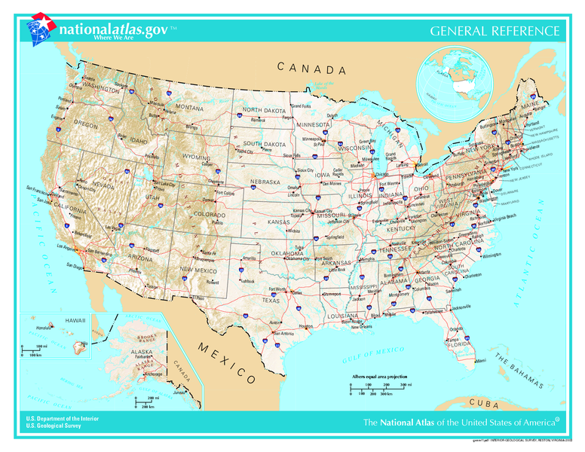
- Sequoia National Park
- New Orleans
- Everglades National Park
- San Francisco
- New York
- Grand Canyon
- Niagara Falls
- Washington, D.C,
- Kennedy Space Center
- Las Vegas
- Mount Rushmore
- Los Angeles

- National park created by the Colorado river
- The largest city of the USA (Big Apple, Statue of Liberty)
- Faces of American presidents carved in the rock
- Big city in the mouth of the Mississippi river known for the festival Mardi Grass and a cradle of jazz music
- Capital city of the USA
- National park in Florida known for crocodiles
- City in the west of the states known for the Golden Gate bridge and cable street cars
- Place where the spaceships are made
- 2nd largest city of the USA lying in the west with the world´s famous film centre – Hollywood
- National park famous for very big trees
- Huge mass of water falling down between two large lakes in the border of the USA and Canada
- The world´s largest gambling centre

- Choose the correct answer.

- Where can you find the White house, Capitol and the Pentagon?
- New York
- Washington, D.C.
- Los Angeles
- The Great Lakes don´t include
- Salt Lake
- Michigan
- Superior
- Mt. Mac Kinley – the highest mountain of the USA is in
- Hawaii
- Alaska
- Nebrasca
- Beverly Hills – the best place for rich people is in
- Las Vegas
- New York
- Los Angeles
- The city which we can see from the Alcatraz (former strict prison) is
- Los Angeles
- New Orleans
- San Francisco
- The part of New York attacked by the terrorists on 11th September 2001
- Manhattan
- Brooklyn
- Bronx

Seznam použité literatury:

Wikimedia commons

Testové úlohy a cvičení jsou autorsky vytvořeny pro učební materiál.

